**Static voltage Indexes**

**Requirements:**

* To check whether the operational limit of the transmission lines has been breached.
* To check whether steady state is reached.

**Proposed Method:**

Since the requirements for Overload and Over/Under voltage indices are same, we propose the same computation approach with the following differences:

* Over-voltage limit: Previously, this value was taken as the average of the initial set of points in the simulation. It will be replaced to use an over-voltage limit provided by the iTesla toolbox for each line/bus; otherwise, 5% pu outside the nominal voltage is assumed.
* Under-voltage limit: Similar to the above point, a value of the under-voltage limit provided by the iTesla toolbox for each line/bus, otherwise, we will assume 5% pu outside the nominal voltage.
* Final indexes will be organized in the same way as the overload index.

**Over/under voltage Index-Theory:**

$$v_{x}=\sum_{i=1}^{N_{b}}{wv_{i}{\left(\frac{v_{init,i}-v_{post,i}}{{∆v}_{i}}\right)}^{q}},{∆v}_{i}=\frac{v_{max,i}-v_{min,i}}{2}$$

Where v_x is the performance index for the operating point x, Nb is the number of buses to be analyzed, $v_{init,i}$ is the initial voltage at the ith bus before any disturbance occurred (pre-fault value), $v_{post,i}$ are the average voltage of the post fault data at the ith bus. *wvi* is a weighting factor of each bus, which can be defined by the best judgment of the system operator, for instance *wv* = [1, 1, ..., 1] for unitary weight in all buses. $v_{max,i}$ and $v_{min,i}$ are the upper and lower voltage limits for the *i*th bus, respectively and *q* is an exponent to reduce masking effects, which means that a high value of the exponent will scale the effects of violations in the voltage limits resulting in a large index value. The final value of the over load index v_x is a scalar, and its interpretation is as follows:

$v_{x}=1-→$ All buses are within the limits

$v_{x}>1-→$ At least one bus has violated its limit

$v_{x}≫1-→$ A severe violation has occurred

The state of the voltages at the bus is assessed based up on the difference in slope of the voltage variation of the bus at the end of simulation. Three intervals, each of size 25 samples is considered in the given data from the end time of simulation. The average slope of each interval is calculated (S1,S2,S3). The difference in slope between first two intervals and last two intervals is calculated. If the difference is less/zero implies that the power flow variation in that particular line is reduced.

The final outputs of the over/under voltage index calculation are the following,

* v_x is the final Under/Over voltage index of the given system.
* ‘F’ is a matrix, which gives the voltage level of each bus as per the index calculation. F=[F1; F2; F3…;Fn] where if Fn >>1 indicates that the operational limit is violated.
* ‘f’ is a matrix, which gives the list of buses that violated operational voltage limit.
* ‘G’ is a matrix, which gives the state of the buses. G=[G1; G2; G3…;Gn] where if Gn >>1 indicates that the buses has not reached steady state.
* ‘g’ is a matrix, which gives list of the buses that are yet to reach steady state.

**Simulation Results:**

The main execution file for voltage stability indexes is ‘static_voltage _index_testing‘. The execution of this file is explained below with ‘OverUnder_Voltage’ file. The Matlab function ‘static_voltage calculates the indexes and identifies the voltage violated buses in the given data file.

* The state of the voltages at the buses is assessed based up on the difference in slope of the voltage variation of the bus at the end of simulation.
* Three intervals, each of size 25 samples is considered in the given data from the end time of simulation.
* The average slope of each interval is calculated (S1, S2, S3).
* The difference in slope between first two intervals and last two intervals is calculated.
* If the difference is less/zero implies that the power flow variation in that particular line is reduced.

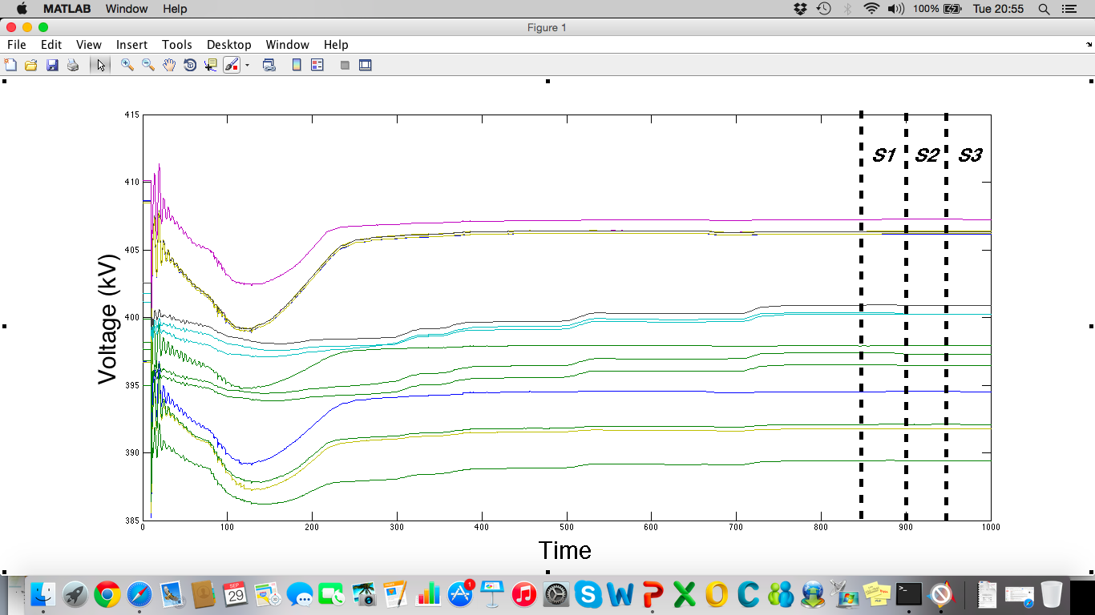

Figure-1